Experiment 26：MPU6050
Mpu6050 is the world's first integration of the 3 axis gyro, 3 axis accelerator, including 9 axis fusion
application
Motion sensing game
Augmented reality
EIS: Electronic Image Stabilization
OIS: Optical Image Stabilization
Pedestrian navigation device
Zero touch gesture user interface
Postural shortcuts
Certification market
Intelligent mobile phone
Flat plate device
Handheld game products
recreational machines
3D remote control
Portable navigation device

Connection method：
A4 connect SDA
A5 connect SCL
VCC connected to 3.3V (also can be connected to the 5V, but for the sake of the sake of insurance, it is best to connect 3.3V)
GND connected to GND.
Physical diagram is as follows：
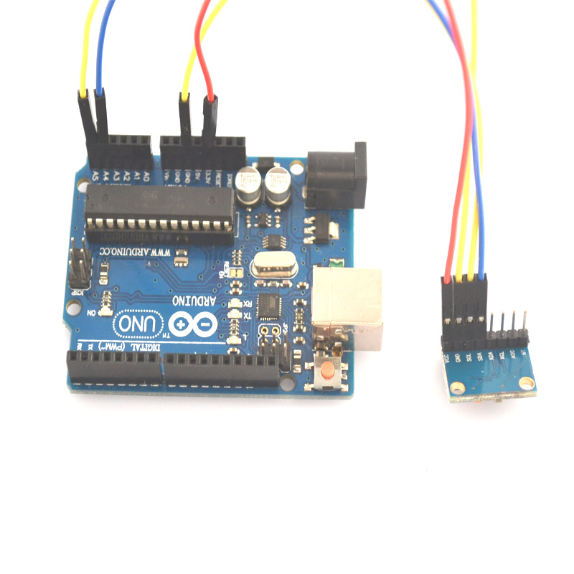

But MPU affected by the accuracy of the temperature difference is relatively large！

The following is the program code：
#include "Wire.h"
#include "I2Cdev.h"
#include "MPU6050.h"
MPU6050 accelgyro;

int16_t ax, ay, az;
int16_t gx, gy, gz;

bool blinkState = false;

void setup() {

Wire.begin();
Serial.begin(38400);

accelgyro.initialize();
}
void loop() {

accelgyro.getMotion6(&ax, &ay, &az, &gx, &gy, &gz);
Serial.print("a/g:\t");
Serial.print(ax/16384); Serial.print("\t");
Serial.print(ay/16384); Serial.print("\t");
Serial.print(az/16384); Serial.print("\t");
Serial.print(gx/131); Serial.print("\t");
Serial.print(gy/131); Serial.print("\t");
Serial.println(gz/131);
blinkState = !blinkState;

}
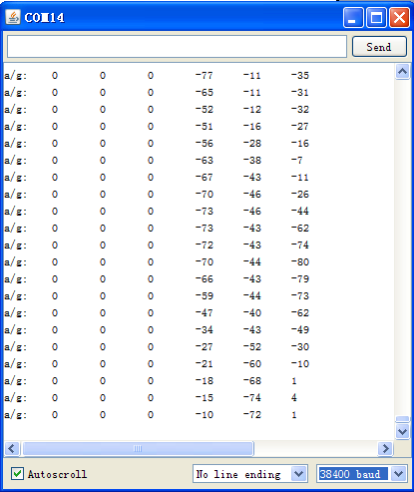
Some of the results of the above deviation, the reason is not corrected, this is just to give you a reference, I hope to help you thank you

